**Malawi Compost Transporter**

**Final Proposal**

**Husain Aldawood**

**Connor Schmerfeld**

**Hope Williams**

**Shi Zhang**

**Fall 2020**



**Project Sponsor/Faculty Advisor/Sponsor Mentor:** Dianne McDonnell

**Instructor:** David Trevas

# **DISCLAIMER**

This report was prepared by students as part of a university course requirement. While considerable effort has been put into the project, it is not the work of licensed engineers and has not undergone the extensive verification that is common in the profession. The information, data, conclusions, and content of this report should not be relied on or utilized without thorough, independent testing and verification. University faculty members may have been associated with this project as advisors, sponsors, or course instructors, but as such they are not responsible for the accuracy of results or conclusions.

# **EXECUTIVE SUMMARY**

Malawi is a small landlocked country in the southeastern region of Africa. It is also considered one of the poorest countries in the world, located in the southeastern region of Africa. To make better use of organic materials found in Malawi, locals have set up composting sites where residents can dispose of compostable materials. To ease the transport of this compostable material, Team Malawi has been tasked to design and engineer a tricycle that can transport compost from tightly packed neighborhoods to the composting sites.

Team Malawi was given this project last semester, spring 2020, as a ME 386W project. The team has now decided to continue this project and build the device to help the people of Malawi. Our team started this project by talking with our client, Dr. McDonnell, and understanding what her needs and the people of Malawi’s needs are. After meeting with the client, the team was able to come up with constraints and requirements for the design. After weighing the customer needs and engineering requirements, Team Malawi created design alternatives and scored each with the given criteria. This process was done by making charts such as a morphological matrix, pugh chart, and decision matrix which can all be seen below. This process left the team with a final design that met all of the engineering requirements and customer needs. The cart will be powered by two batteries and an AC Motor that has enough capacity and power to run the vehicle. The team also made a rough CAD model to represent the design in a three-dimensional view. The total cost of the design before tax the team has calculated is $1222.63. This number is well below the budget our client has provided us which gives the team some room to make more purchases if needed during the trial and error stage. The following spring 2021 semester will consist of building and testing our final device in order to hopefully achieve a successful vehicle to help the people of Malawi.

# **TABLE OF CONTENTS**

Contents

**DISCLAIMER** **1**

**EXECUTIVE SUMMARY** **2**

**TABLE OF CONTENTS** **3**

**BACKGROUND** **4**

Introduction 4

Project Description 4

**REQUIREMENTS** **5**

Customer Requirements (CRs) 5

Engineering Requirements (ERs) 5

Functional Decomposition 6

Black Box Model 6

Functional Model/Work-Process Diagram/Hierarchical Task Analysis 7

House of Quality (HoQ) 7

Standards, Codes, and Regulations 8

**Testing Procedures (TPs)** **8**

Testing Procedure 1: Weight Testing 8

Testing Procedure 1: Objective 8

Testing Procedure 1: Resources Required 8

Testing Procedure 1: Schedule 8

Testing Procedure 2: Power Testing 9

Testing Procedure 2: Objective 9

Testing Procedure 2: Resources Required 9

Testing Procedure 2: Schedule 9

**DESIGN SELECTED – First Semester** **10**

Design Description 10

Implementation Plan 10

**CONCLUSIONS** **12**

**REFERENCES** **13**

**APPENDICES** **16**

Appendix A: All six of the Design Alternatives. 16

Appendix B: Important Tables 18

# **BACKGROUND**

## ***Introduction***

Apart from being a small landlocked nation in Africa’s southeastern region, Malawi is also regarded as one of the world’s poorest countries. For better utilization of organic materials found in this country, residents have set up places for disposing of compostable waste materials. To ensure easy transportation of these compostable waste material, our team has been mandated to design and make a tricycle that is able to transport compost to the composting location. The group was acquainted with the customer that will be with us for the degree of the semester and further if the venture is to be proceeded. In the wake of meeting with the client, the group had the option to concoct imperatives and prerequisites for the plan. Subsequent to gauging the client's needs and designing prerequisites, The team made plan options and scored each with the given measures. This cycle was finished by making diagrams, for example, a morphological framework, pugh outline, and choice grid which would all be able to be seen beneath. This cycle left the group with the last plan that met all of the designing necessities and client requires. A lithium ion battery with sufficient capacity will be used to power the tricycle. A CAD model was made as a representation of the design in a 3-dimensional view. Cost analysis of the design can also be seen below as well so the team is prepared how much the final design will cost if chosen to manufacture. Through the design process that is shown below, our team has come up with an optimal design that will improve the lives of the people of Malawi. This project proposal is a compilation of all work that was put into the design of the compost transporter in Malawi. The information inside this update start from the earliest starting point of the undertaking, which is the difficult definition. This incorporates the client’s needs, designing prerequisites, and a figure of the QFD that was made joining the two. The group was then ready to contemplate distinctive designing investigations of the plan. In the wake of having a rough drawing of what the last plan will resemble, the group planned a CAD model. From the CAD model, the group had the option to deliver some cost analysis. This incorporates a bill of materials, the assembling cost, the existence cycle cost, the worth examination, and a period estimation of cash. Ultimately, on the report will be a code of morals that incorporates the conceivable moral issues the group may experience.

## ***Project Description***

The main goal of this project is to design and make an electrically propelled tricycle that will allow Malawians to transport organic waste materials from their home to compost sites. Organic waste entails but is not limited to garbage, junk, and any other materials considered pollutant to the environment due to their toxicity. The partners for the task incorporate the individuals of Malawi who will be working the vehicle. Another partner is the whole nation of Malawi in light of the fact that, if fruitful, the tricycle will improve the work of the entire Malawian populace. The group accepts that the necessities of the customer and the partners are fundamentally the same as and meet the general objective. To address their issues, the vehicle should be effectively viable and manufactured with some normal homegrown materials to ease fixes. The vehicle additionally should be anything but difficult to work with practically zero electrical information required. Being lightweight and smaller is extremely useful as long as it is as yet ready to keep up a high payload limit and strength. The objective satisfies these necessities by assessing all client requirements and applying an answer for all prerequisites the clients needed.

# **REQUIREMENTS**

When meeting with the client, the team came up with a list of customer needs that must be met in order to satisfy the client. After the customer needs were developed, the team came up with a list of engineering requirements within the QFD. A more in-depth lists of customer needs and engineering requirements

## ***Customer Requirements (CRs)***

The group met with Professor McDonnell and she gave us a list of requirements that she would like to see in the project. She broke it down into two individual groups: must have, and nice to have. These two lists can be seen below with more detail.

**Must Have:**

* Maintainable
* Manufacturable
* Durable
* Lightweight
* Easy to Operate
* Maneuverable Size
* Operable on Muddy Roads
* Cost within budget
* Durable and Robust design
* Reliable design
* Safe to operate

All of the items in the above list are items that the project needs to have, according to the professor and instructor. It must be maintainable, as Malawi as a poor country and can’t be constantly buying new parts. It must be manufacturable, since the end goal is to be able to make multiple for this country. Durable, lightweight, and operable on muddy roads are all needed because there are basically no paved roads and this design is going to be in constant use. It must be reliable for this same reason, as well. It needs to be safe and easy to operate, as these will be everyday people using this. Finally, it needs to be within the budget of $1,500, as told by the instructor.

**Nice to Have:**

* High Capacity
* Rechargeable
* Reusable Materials Found in Malawi

These “nice-to-have” items listed above were given by the client as things to think about when making this project, but not necessarily adding them in right away. She did this because this project is going to go well past the year this group was given, so she wants this group to give future groups a good jumping off point, where they can hopefully include these if they aren’t already included.

## ***Engineering Requirements (ERs)***

After hearing what the client wanted for this project, the group decided to come up with a list of engineering requirements to think about when designing. The engineering requirements are items that are measurable and items that we are able to discuss, quantitatively. This list can be seen below.

1. Increase Power
2. Small Dimensions
3. Increase Waste Capacity
4. Increase Battery Life
5. Decrease Weight
6. Decrease Manufacturing Cost
7. High Level of Safety

Power is something that the group will constantly need to think about, as this will be dealing heavily with electric motors and carrying a load capacity. The design should have smaller dimensions, but still maximize load capacity for travel as well as storage. This design should take up as little space as possible without making it useless in terms of waste capacity. Along with these items is weight. The design should be as light as possible due to muddy roads and the possibility of getting stuck. The civilians should be able to push or pull the design out, maybe with the help of multiple people. Finally, the group is going to be constantly thinking about the manufacturing cost. This is due to being restricted by the budget, as well as the Customer Need of wanting to one day make multiple.

## ***Functional Decomposition***

To start designing a cart which meets all of our customer and client needs, we made a black box model to breakdown the inputs and outputs of this design. Using this information, we made a functional model to further break down the inputs and outputs. A figure of both of these can be seen below as well as a more in depth description.

### **Black Box Model**

This section discusses the Black Box Model of this project. A Black Box Model allows the group to focus solely on the inputs and outputs of this project without having to worry about the details of how to get from one to another. The Black Box can be seen below.

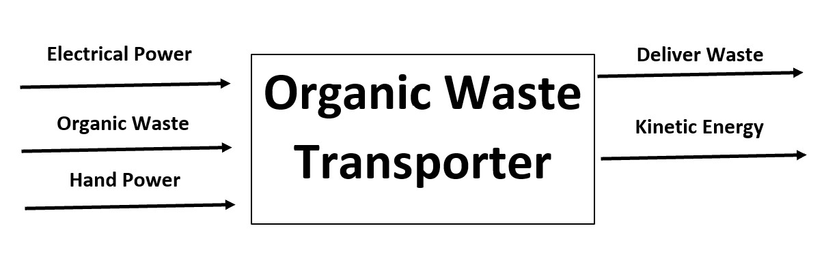

Figure 1: Black Box Model

The primary inputs of the design are electric and hand power, as well as organic waste. The outcome of this design will deliver waste as well as outputting kinetic energy. A Black Box model is important when starting a project because it allows the group to see the bigger picture and get a scope of what the project is going to need. It also allows the group to start thinking about what is inside of the “Black Box”.

### **Functional Model/Work-Process Diagram/Hierarchical Task Analysis**

### 

Figure 2: Functional Model

A functional model is a graphical description of the functions (or operations) a product must perform on input flows to transform them into desired output flows. Sub-functions may be derived from customer needs. Then solutions to sub-functions can be directly tied to the customer's needs. All in all, according to the function allocation of the functional model, it can help the team to more specifically clarify the availability of designs.

## ***House of Quality (HoQ)***

After taking all the data, we began to analyze the information and compiled it into a more useful form. This form is known as the QFD chart. This is a chart used by engineers to focus on what they are trying to accomplish. In this chart, the customer needs and engineering requirements of such a device are analyzed and compared in order to better understand what this device needs to do. The scale used in this QFD is a standard scale of importance. After computing the absolute technical importance of each engineering requirement, our team came to the three most important engineering requirements: 1. High level of safety 2.Increase power 3. Small dimensions.

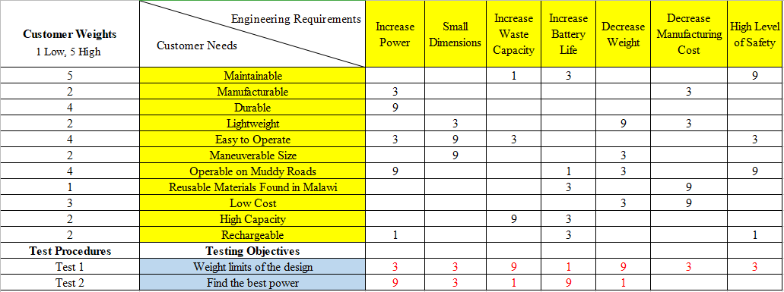Figure 3: House of Quality

Updates to the QFD include added testing procedures and their quantitative relationship to the engineering requirements. Tests are listed below the customer requirements section, including two tests that ensure the operation of all main components. The relationship correlation between tests and engineering requirements are depicted in red.

## ***Standards, Codes, and Regulations***

The only standards this project requires is a dimensioning standard and the customer and clients needs. The only reason a dimensioning standard is needed is so that the design can be converted between dimensions or be given specific tolerances. Because this is a new project, there are no regulations associated with it and our goal is to simply come up with the most efficient and affordable design to support our client.

# **Testing Procedures (TPs)**

The team collectively decided that the only two Engineering Requirements that needed proper testing was the waste capacity/weight, and the power. This was decided because the rest of the engineering requirements go hand-in-hand with these two and they can also be found using calculations only. The capacity and weight will both be tested with one procedure, as the maximum capacity can be determined through the maximum weight. The power can be determined through gear ratios. The right gear ratio can give the desired power to the wheels. Both of these tests will use the speed of the cart as a reference to what is desired. The battery life may also be used but this may vary during each trial.

## ***Testing Procedure 1: Weight Testing***

This procedure will test the weight limits of the design. This test will be conducted so that the group will know what to market the best loading capacity. This test will be conducted by continuing to add weight until the desired power/speed is no longer reached. This will determine the maximum recommended capacity.

### **Testing Procedure 1: Objective**

While not decided on completely, the team will most likely use a set of lifting weights so that they can have an accurate weight to measure. After each weight is added, the cart will be tested and the power and speed will be recorded. Once a value goes below the desired one, the test will be over and the final weight will be recorded as the maximum. This is to ensure that the people of Malawi are given an accurate capacity so that they know what not to go over.

### **Testing Procedure 1: Resources Required**

The whole team will most likely be required to get the most accurate results. A stopwatch will also be necessary to record the time it takes to travel a certain distance. This will be used to calculate the speed. A set of weights will also be needed to accurately stack the amounts up.

### **Testing Procedure 1: Schedule**

The test should not take any more than one day to complete. Most calculations can be completed during the test, if not right after. This test, however, will need to be done only after the design or prototype has been assembled.

## ***Testing Procedure 2: Power Testing***

This test will be conducted in order to find the best power for the given problem. This test needs to be conducted because too much power would cause the design to be too fast for walking, while too little would cause it to be too slow for rougher areas. A proper gear ratio will allow for proper power transfer and a proper power amount.

### **Testing Procedure 2: Objective**

Prior to this test, a set of calculations will need to be conducted in order to narrow the gear ratios down to only a few. From there, the right gears for these ratios will be purchased, then each one will be tested by using the speed of the cart as a reference. The gear that provides the best results will be the one used, and the other prototypes will be scrapped.

### **Testing Procedure 2: Resources Required**

The entire team should attend this test in order to achieve the most accurate results. On top of this, multiple gears will be needed to purchase and/or 3D-printed in order to test a variety of different gear ratios. A stopwatch will also be used to determine the time to travel a certain distance, which will then be used to calculate the speed.

### **Testing Procedure 2: Schedule**

This test could be done in one of two ways. The first way would be testing it each day that a new gear came in, and calculating the results of that gear per day. The second way would be to wait until all gears have been delivered or made and test all of them in one day. Either way wouldn’t be too time consuming and each one has their own benefits. The team would discuss this as the time came. Either way that this test is done, a prototype will need to be completed before starting the test.

# **DESIGN SELECTED – First Semester**

In Designs Selected, we will combine the subsystems we come up with and create the concepts. Then we got our six designs which are shown in Appendix A. Firstly, we will use the Pugh Chart to narrow six designs down to three by ranking them based on customer needs. Then we will use the Decision Matrix to decide our top one design based on engineering requirements. Another design will be decided by team members to make up for the deficiencies of the design selected by decision matrix. The design selected includes a combination of the parts the team found most beneficial as well as some of the customer and clients requirements.

## ***Design Description***

The final design of the project has changed a lot since the beginning of the semester. The group has decided to go with a design that resembles a modified GorillaCart rather than a deep-bucket-like design. The original idea was to use 8020 Aluminum for the whole cart, but ultimately it was decided that it would be best if it were only used for the frame with an aluminum plate being the base of the bucket.. This is due to the complexity of the profile of 8020 Aluminum as well as prices. This is also to make access to the batteries and motor easier for when someone may need to work on or replace it. The dumping mechanism has also changed a lot. The final design has a removable wall with the bucket on hinges. A hydraulic jack will be used to raise the bucket on one side by pumping it manually rather than electronically (another design change) and will dump the load off the other side where the removable wall is. The tires will be off-road tires and filled with foam to prevent punctures. The motor system has also been finalized to be a DC motor with a twist-throttle on the handle to activate it when necessary. The final design also implements a handle in the back if a second person is needed to haul the load. The cart will have a carriage underneath the bucket that is capable of holding the batteries needed, as well as the hydraulic jack and motor. While a prototype has not yet been made, an image of the CAD model can be seen below.

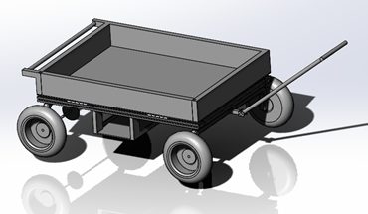

Figure 4: CAD Model of Final Design

## ***Implementation Plan***

The plan going forward is to create a prototype or proof of concept. This will allow the group to show that the design is realistic and can further their project to create the final product. Information that will be needed for the final design will include the results of the tests from above, as well as the durability and strength of the given materials. Finalizing the dimensions after the prototype will also be used to create the final design. Everyone on the team is a valuable asset to the project, and the client and instructor are useful sources to refer to when building the design. A representative from the 80/20 company may be used but isn’t completely necessary. The materials that will be used will be mostly aluminum. Some standard steel may be used for smaller components such as the handle. Parts such as the motor, jack, axles, and gears can all be outsourced from other companies. Facilities that may be used during the process include the Machine Shop, the team’s houses, and possibly other places with the desired equipment for use. A Bill of Materials can be found in Appendix B.

For the second semester, the initial plan is to have a proof-of-concept either completed or close to completion. It is also a plan to have the parts necessary to start construction. As the building process progresses, small changes may need to be made in order to fit the desired outcome. Once construction is complete, tests will be conducted to determine the proper gear ratio as well as the maximum capacity. Any parts of our budget may be used to replace any parts that may be broken in this process. From there, a presentation to the client will be conducted and their input will be given to make any small adjustments.

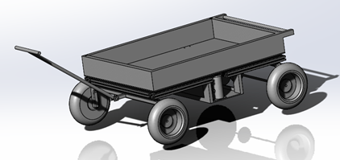

Figure 5: Another View of the Assembled Design.

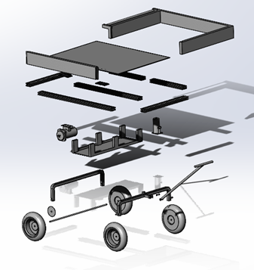

Figure 6: An Exploded View of the Design.

# **CONCLUSIONS**

This report started with discussing the background of the project, and discussing both the engineering and customer requirements. From there, the testing procedures that will be conducted next semester were discussed as well as the final design of the semester. Finally, all of the future plans for next semester were discussed towards the end of the report.

In conclusion, this project is at a good place for the end of the semester. Throughout this semester, the group was able to make multiple calculations and piece together multiple components to produce a viable and worthy design for this project. The topics of this semester were discussed in this report as well as the plan for next semester. Next semester, the group is planning on building a prototype right away and start conducting multiple tests to get to the desired outcome. From there, the client will be able to give input and tell the group to make any modifications necessary for them to be content with the final product. With a good final design in possession, the team will be prepared to tackle all of the tasks at hand for the next semester.

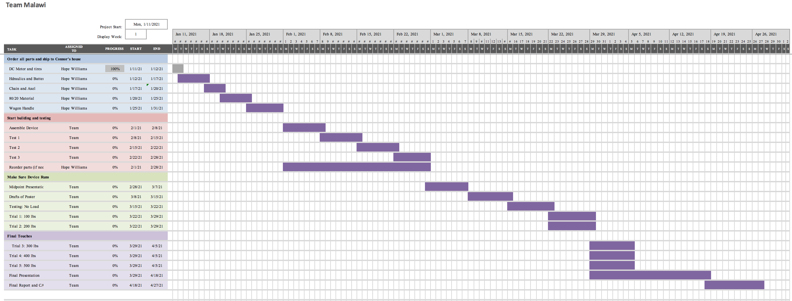

Figure 7: Spring 2021 Gantt Chart

# **REFERENCES**

[1] N. Takesue, Y. Komoda, H. Murayama, K. Fujiwara and H. Fujimoto, "Scissor lift with real-time self-adjustment ability based on variable gravity compensation mechanism", *Advanced Robotics*, vol. 30, no. 15, pp. 1014-1026, 2016. Available: 10.1080/01691864.2016.1181008.

[2] A. Noormohamed, O. Mercan and A. Ashasi-Sorkhabi, "Optimal Active Control of Structures Using a Screw Jack Device and Open-Loop Linear Quadratic Gaussian Controller", *Frontiers in Built Environment*, vol. 5, 2019. Available: 10.3389/fbuil.2019.00043.

[3] P. Gallina, "Vibration in screw jack mechanisms: experimental results", *Journal of Sound and Vibration*, vol. 282, no. 3-5, pp. 1025-1041, 2005. Available: 10.1016/j.jsv.2004.03.036.

[4] Xiang Sunshou Seeks Patent for Garbage Recycling Vehicle with Hydraulic Lifting Rods. (2018). Global IP News. Environmental Patent News, pp. Global IP News. Environmental Patent News, 2018-04-08.

[5] J. Wang, Z. Qi and G. Wang, "Hybrid modeling for dynamic analysis of cable-pulley systems with time-varying length cable and its application", *Journal of Sound and Vibration*, vol. 406, pp. 277-294, 2017. Available: 10.1016/j.jsv.2017.06.024.

[6] 8020.net. 2020. *Resources To Learn More About T-Slot Products And Narrow Down Your Options.*. [online] Available at: <https://8020.net/product-basics#> [Accessed 19 October 2020].

[7] Budynas, R., 2019. *SHIGLEY's MECHANICAL ENGINEERING DESIGN*. 8th ed. MCGRAW-HILL EDUCATION.

[8] Orosz, I., 1970. *Simplified Method For Calculating Shear Deflections Of Beams*. Madison, WI: USDA Forest Service, Forest Products Laboratory.

[9] Engineeringtoolbox.com. 2008. *Aluminum Alloys - Mechanical Properties*. [online] Available at: <https://www.engineeringtoolbox.com/properties-aluminum-pipe-d_1340.html> [Accessed 19 October 2020].

[10] Megson, T., 2005. *Structural And Stress Analysis*. 2nd ed. Boston: Elsevier Butterworth Heineman.

[11] Lowe's. 2020. *CRAFTSMAN 6-Cu Ft Steel Wheelbarrow*. [online] Available at: <https://www.lowes.com/pd/CRAFTSMAN-6-cu-ft-Steel-Wheelbarrow/1000737276> [Accessed 19 October 2020].

[12] Amazon.com. 2020. *Gorilla Carts GORMP-12 Steel Dump Cart With Removable Sides And 2-In-1 Convertible Handle, 1,200-Pound Capacity, 39.5-Inch By 22-Inch Bed, Grey Finish*. [online] Available at: <https://www.amazon.com/Gorilla-Carts-GORMP-12-Removable-Convertible/dp/B00814KE5I> [Accessed 19 October 2020].

[13] The best vintage and classic cars for sale online | Bring a Trailer. 2020. *1954 Cushman Truckster Pickup*. [online] Available at: <https://bringatrailer.com/listing/1954-cushman-truckster/> [Accessed 19 October 2020].

[14] University of Colorado Boulder, “8. DC vs. AC Motors - DC Motor Control and Stepper Motors,” *DC vs. AC Motors*. [Online]. Available: https://www.coursera.org/lecture/motors-circuits-design/8-dc-vs-ac-motors-gf0y2. [Accessed: 19-Oct-2020].

[15] All About Circuits, “Brushless DC Motor: AC Motors: Electronics Textbook,” *What's the difference between brushless DC motors and AC motors?* [Online]. Available: https://www.allaboutcircuits.com/textbook/alternating-current/chpt-13/brushless-dc-motor/#:~:text=Brushless DC motors are similar,torque in a magnetic rotor. [Accessed: 19-Oct-2020].

[16] RS Components Ltd., “The Complete Guide toAC Motors,” *Everything You Need To Know About AC Motors | RS Components*. [Online]. Available: https://uk.rs-online.com/web/generalDisplay.html?id=ideas-and-advice/ac-motors-guide. [Accessed: 19-Oct-2020].

[17] Balls Out Motors, “Golf Cart Buying Guide,” *NEW & USED GOLF CART BUYING GUIDE*. [Online]. Available: https://www.ballsoutmotors.com/golf-cart-buying-guide/#:~:text=Most newer golf carts now,more pulling power up hills. [Accessed: 19-Oct-2020].

[18] Electric beach wagons, *Sandhopper.com & Electricbeachwagons.com*. [Online]. Available: https://electricbeachwagons.com/. [Accessed: 19-Oct-2020].

[19] “Why foam-filled tyres are the best choice for your telescopic boom lift,” *Why foam-filled tyres are the best choice for your telescopic boom lift | TVH Parts*, 19-Apr-2019. [Online]. Available: https://www.tvh.com/blog/why-foam-filled-tyres-are-the-best-choice-for-your-telescopic-boom-lift. [Accessed: 19-Oct-2020].

[20] “Manufacture of microcellular foam tires,” *Google Patents*, 20-Jul-2010. [Online]. Available: https://patents.google.com/patent/US5229047A/en. [Accessed: 19-Oct-2020].

[21] N. Ward and T. Young, *The complete guide to glues & adhesives*. Iola, WI: Krause Publications, 2001.

[22] “Effects of Summer Heat on Adhesives,” *Bond Tech Industries*, 22-Jul-2015. [Online]. Available: https://www.bond-tech-industries.com/effects-of-summer-heat-on-adhesives/. [Accessed: 19-Oct-2020].

[23] HNX Media, “Expanding Foam In A Tire,” *YouTube*, 14-May-2019. [Online]. Available: https://youtu.be/chcEBR4h8Is. [Accessed: 18-Oct-2020].

# **APPENDICES**

## ***Appendix A: All six of the Design Alternatives.***

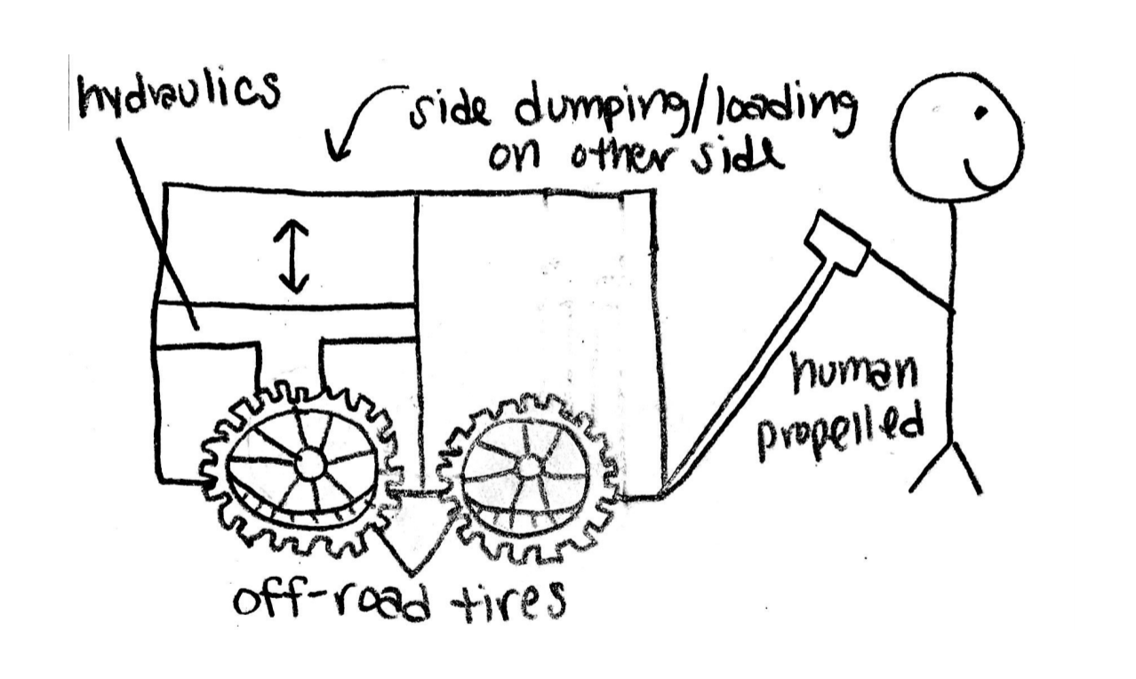

Figure A1: Design Alternative 1

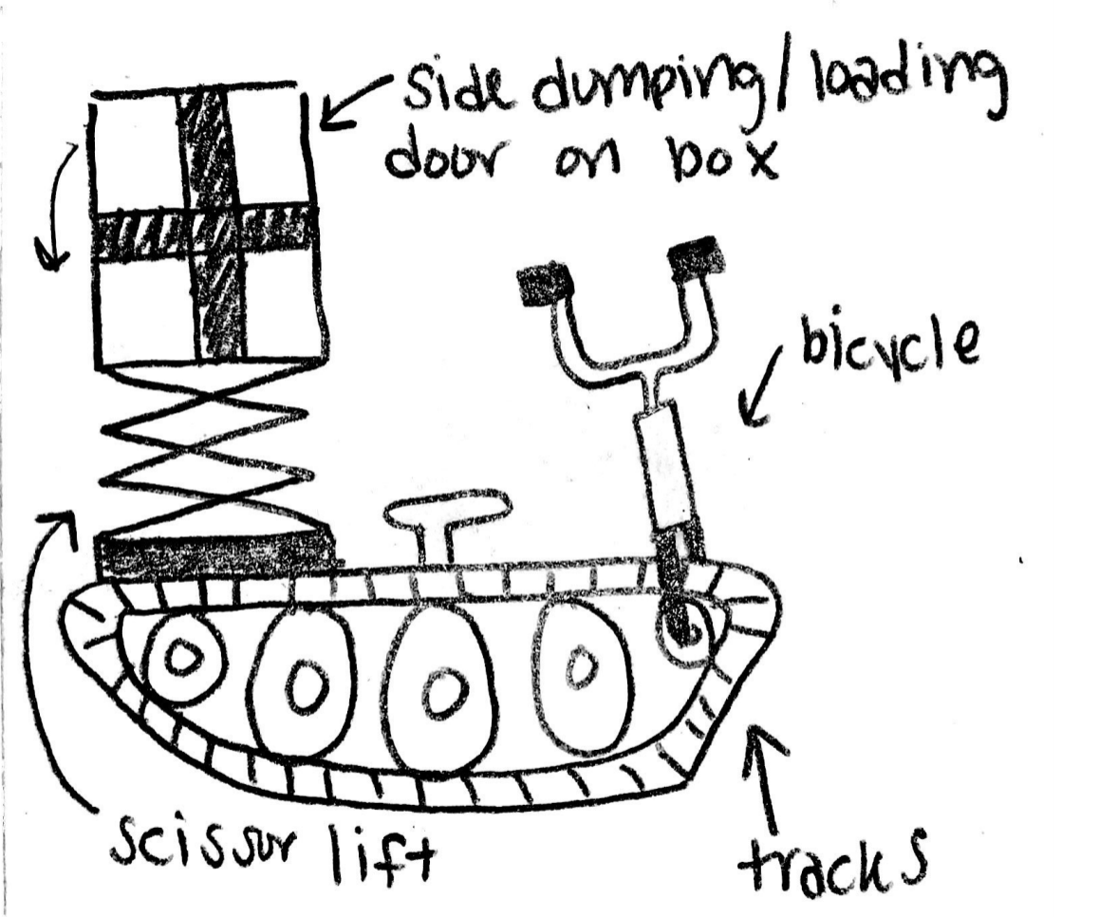

Figure A2: Design Alternative 2

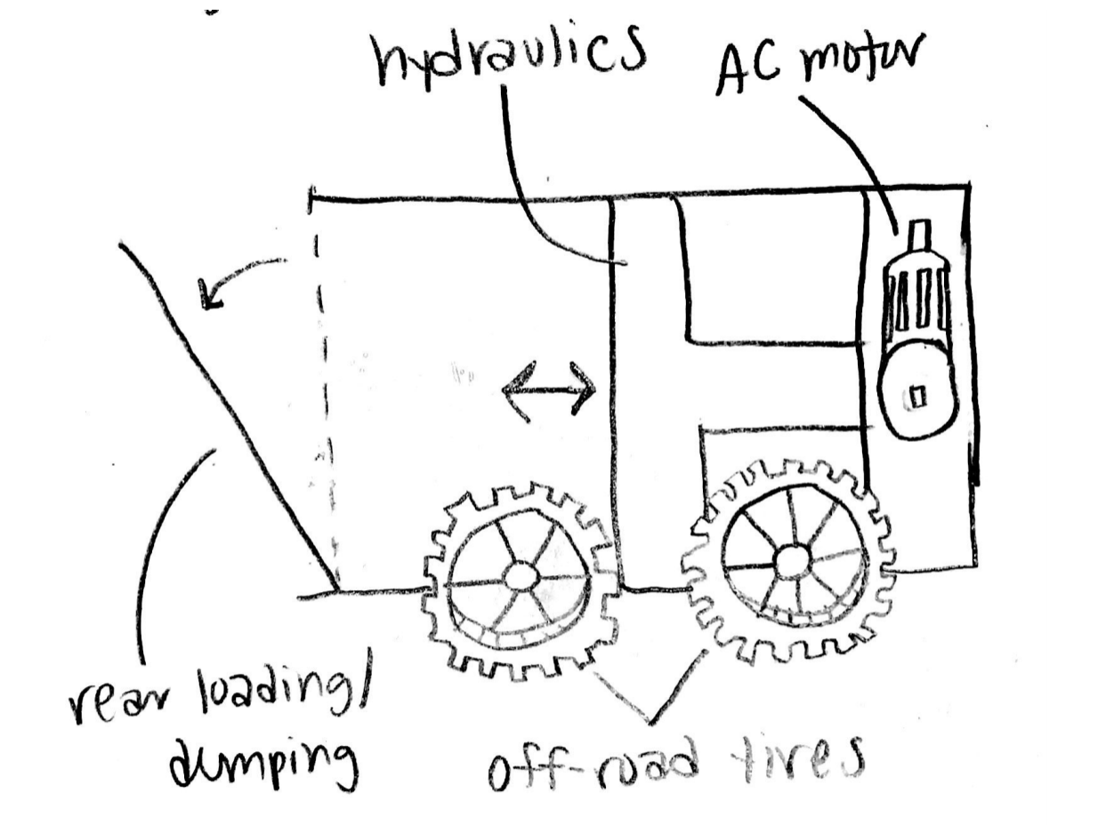

Figure A3: Design Alternative 3

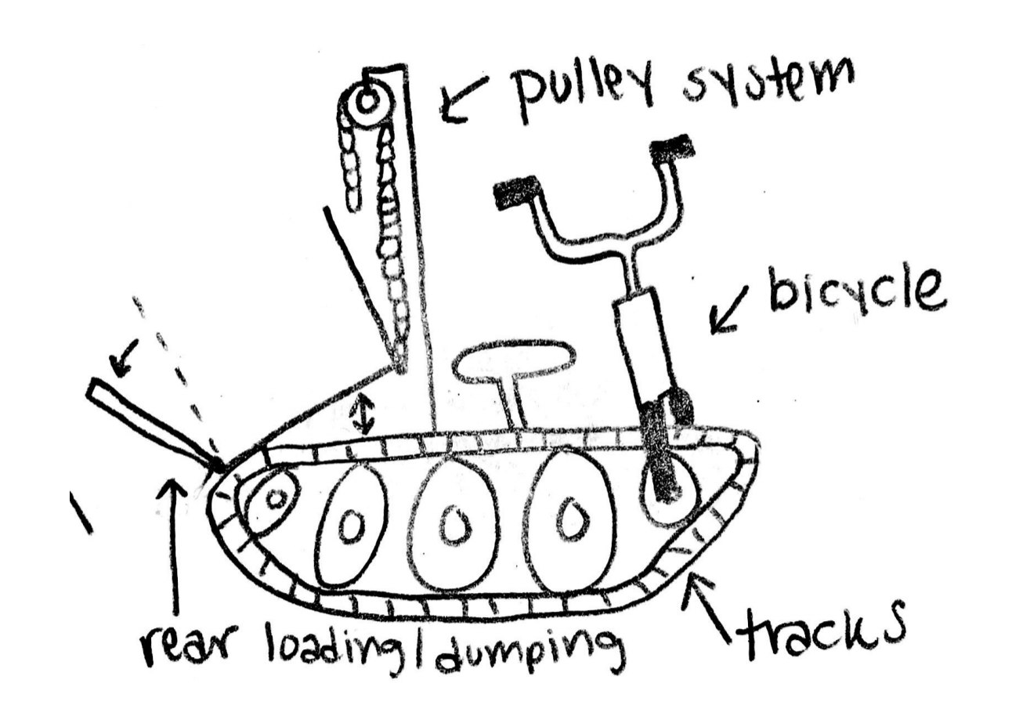

Figure A4: Design Alternative 4

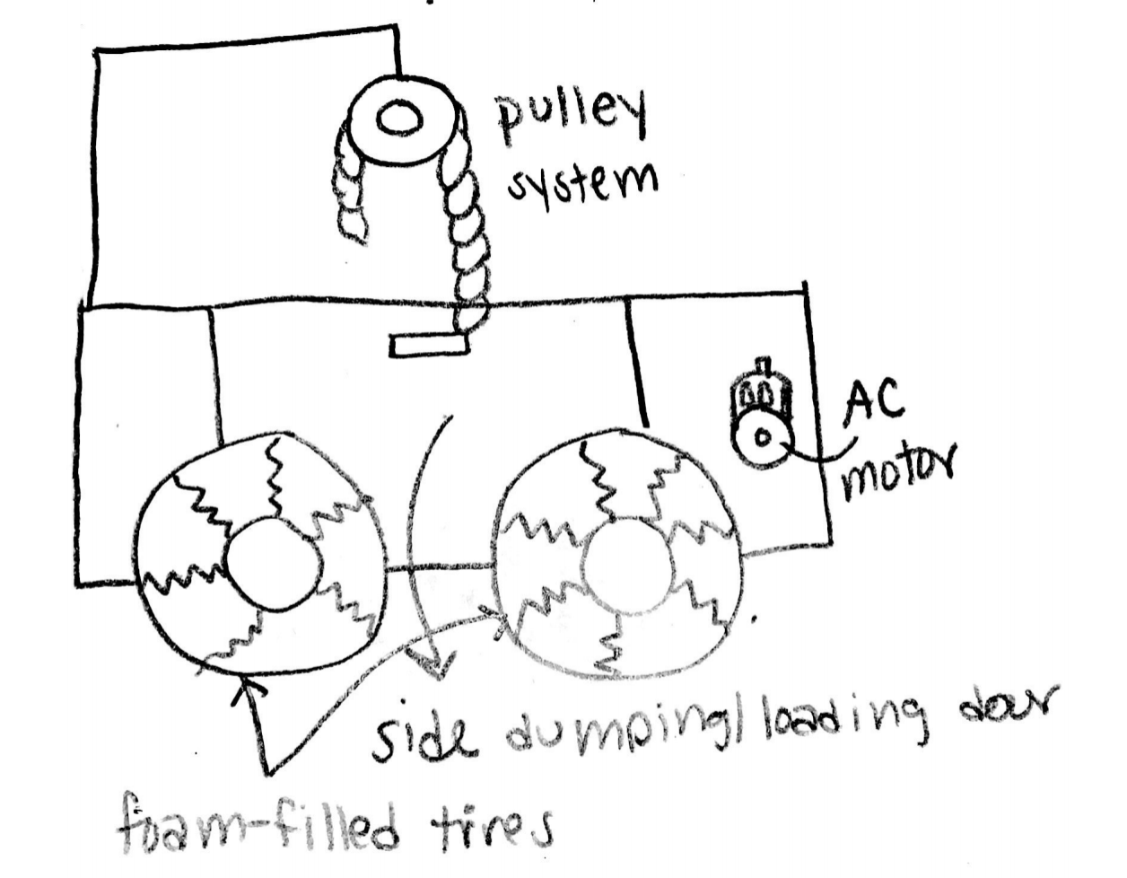

Figure A5: Design Alternative 5

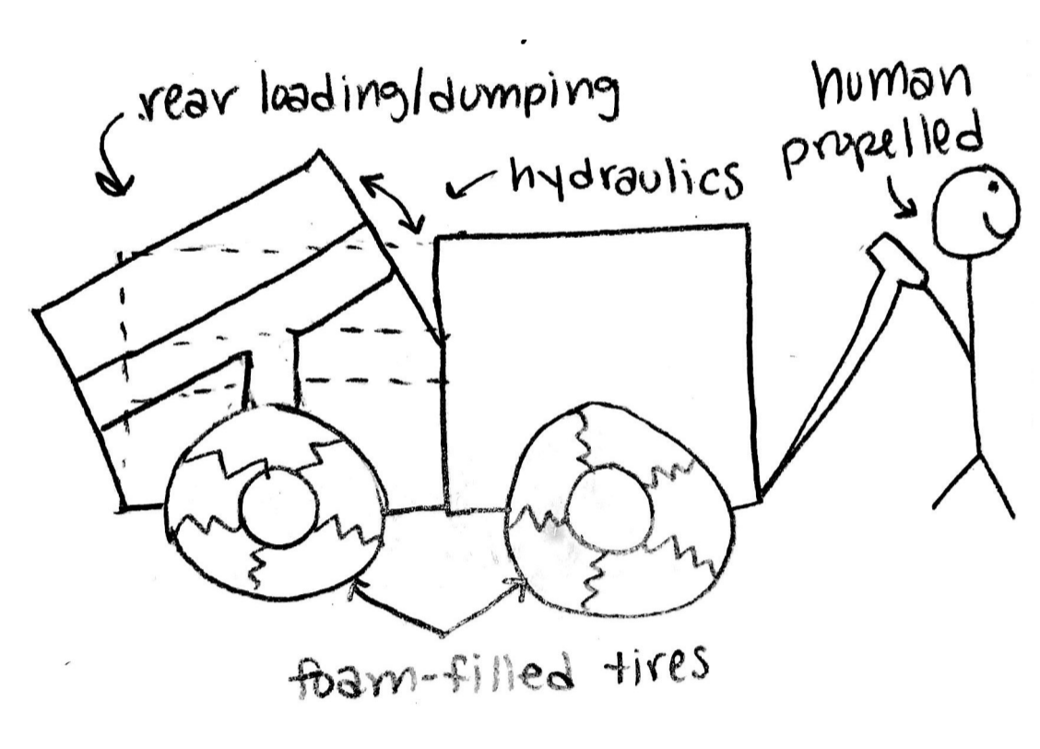

Figure A6: Design Alternative 6

## ***Appendix B: Important Tables***

Table 1: Pugh Chart

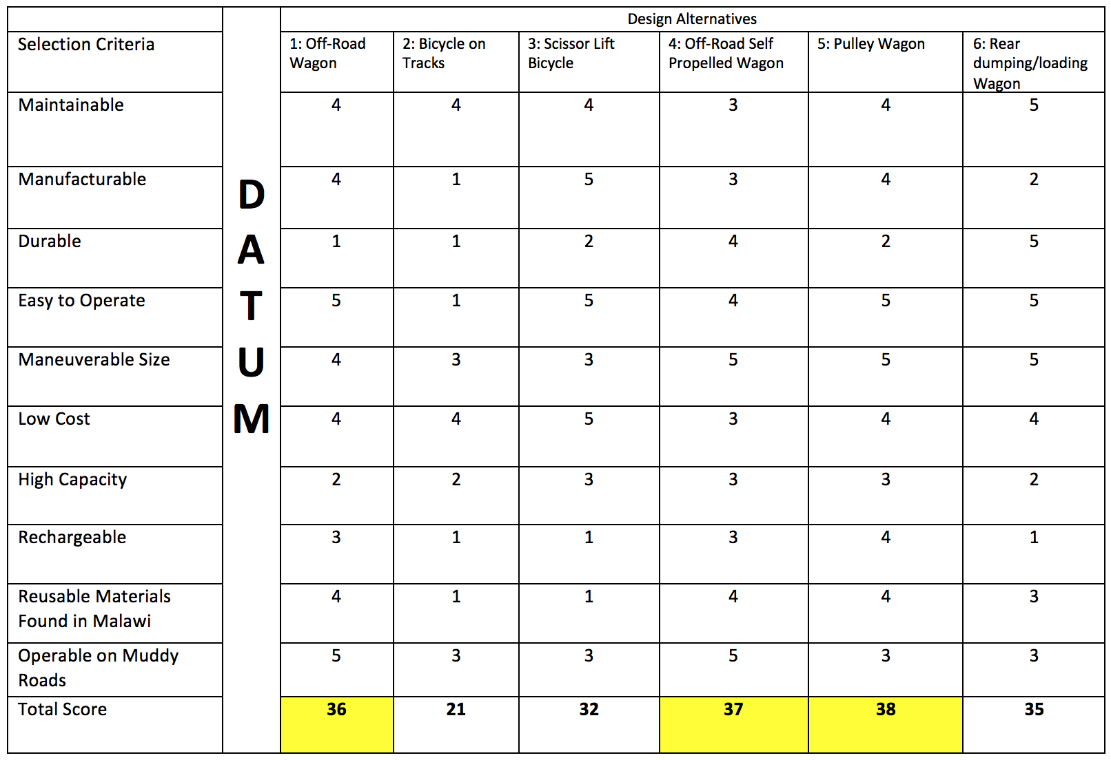

Table 2: Decision Matrix

|  |  |  |  |  |  |  |  |
| --- | --- | --- | --- | --- | --- | --- | --- |
|  |  | Off-Road Wagon | | Off-Road Self Propelled Wagon | | Pulley Wagon | |
| Criteria | Weight (%) | Score | Weighted Score | Score | Weighted Score | Score | Weighted Score |
| Increase Power | 15 | 1 | 0.15 | 4 | 0.6 | 4 | 0.6 |
| Small Dimensions | 20 | 5 | 1 | 2 | 0.4 | 2 | 0.4 |
| Increase Waste Capacity | 25 | 3 | 0.75 | 3 | 0.75 | 4 | 1 |
| Increase Battery Life | 10 | 1 | 0.1 | 3 | 0.3 | 2 | 0.2 |
| Decrease Weight | 10 | 5 | 0.5 | 3 | 0.3 | 3 | 0.3 |
| Decrease Manufacturing Cost | 20 | 5 | 1 | 1 | 0.2 | 1 | 0.2 |
| Total |  |  | 3.1 |  | 2.55 |  | 2.7 |

Table 3: Bill of Materials

|  |  |  |  |  |
| --- | --- | --- | --- | --- |
| Item # | Description | Vender | Quantity (#) | Total Price ($) |
| 1 | Off-Road Tires | Uline | 4 | $92 |
| 2 | Tire Sealant | Slime | 1 | $13.99 |
| 3 | Hydraulic System | TBD | 1 | $17.99 |
| 4 | 80/20 Cart | 80/20 Inc. | 1 | $581 |
| 5 | 80/20 side door | 80/20 Inc. | 1 | $45 |
| 6 | DC Motor | Electric Motor Warehouse | 1 | $125.99 |
| 7 | Chain | TC-Motor | 1 | $19.99 |
| 8 | Batteries | Dakota Lithium | 2 | $258 |
| 9 | Axel | National Hardware Store | 2 | $38.68 |
| 10 | Wagon Handle | Gorilla Carts | 1 | $29.99 |